HTML SYLLABUS (Duration : 1 Month)

1. Introduction to HTML
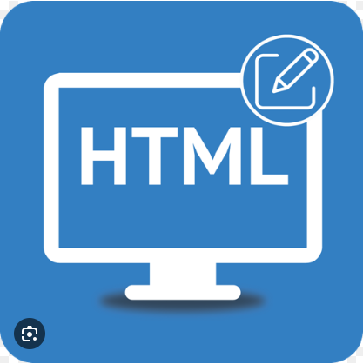
- What is HTML?
- History and versions of HTML
- Structure of an HTML document
- HTML Editors (VS Code, Sublime, Notepad++)
2. Basic HTML Elements
- <html>, <head>, <title>, <body>
- Headings: <h1> to <h6>
- Paragraphs: <p>
- Line breaks and horizontal rules: <br>, <hr>
- Comments: <!-- comment -->
3. Text Formatting Tags
- Bold, Italic, Underline: <b>, <i>, <u>
- Superscript and Subscript: <sup>, <sub>
- Font, style, color (using inline CSS)
4. HTML Attributes
- Global attributes (id, class, style, title)
- href, src, alt, target, width, height
5. HTML Lists
- Ordered List: <ol>
- Unordered List: <ul>
- Definition List: <dl>, <dt>, <dd>
6. HTML Links and Anchors
- Creating hyperlinks: <a>
- Opening in new tab: target="_blank"
- Internal page links
7. HTML Images
- Image tag: <img>
- Attributes: src, alt, width, height
- Image linking
8. HTML Tables
- <table>, <tr>, <td>, <th>
- Merging cells: colspan, rowspan
- Table borders, padding, and alignment
9. HTML Forms
- Form tag: <form>
- Input types: text, radio, checkbox, password, submit
- <label>, <textarea>, <select>, <option>, <button>
- Action and method attributes

